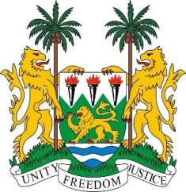
SIERRA LEONE

27th Session of the UPR

FINLAND

3 May 2017

Mr President,

Sierra Leone welcomes the Finnish delegation to this third review cycle and thanks them for their presentation.

My delegation commends Finland on establishing its second National Action Plan on Fundamental and Human Rights for 2017-2019. We note efforts to further protect the rights of persons with disabilities through the enactment into national law of the CRPD and its Optional Protocol in 2016. In 2017, the government also appointed a new Advisory Board for the Rights of Persons with Disabilities.

Furthermore, we note the implementation in 2016 of the national action plan against human trafficking and the government’s engagement in strengthening the national victims assistance system. Sierra Leone would encourage further efforts in this regard, including the strict sanctioning of perpetrators of trafficking in persons.

My delegation also thanks Finland for its commitment to providing international assistance and encourages their continued efforts as regards allocating 0.7% for official development assistance.

Recommendations:

- Implement new measures to ensure victims of rape seek redress and modify the law to ensure the penalties for rape are more severe.
- Provide further support assistance services to better protect victims of domestic violence.

Finally, Sierra Leone wishes Finland a successful completion of its review.

Thank you, Mr President.

